22nd May 2024

Dear Parent/Carer

Year 8 End of Year Assessments

In the first week after half term, Year 8 students will be completing end of year assessments in most of their subjects. These will take place in classrooms and in their timetabled lessons. Students have been told in lesson and via Google Classroom when their assessment will take place.

The assessment for many subjects are those that are used across United Learning Schools. I am aware that the Maths tests will not take place during this week as the Trust are currently adapting the paper; further details will follow and will be sent to you. Rotation subjects may also have a different week for assessment too.

In many lessons this week, students will be taking part in revision and reteaching activities. Homework has also been set on Google Classroom, including use of appropriate online platforms such Seneca to assist with revision. Test results will be included in end of year reports.

Many thanks for your continued support.

Yours sincerely

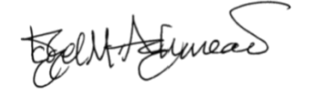

Dr I Ashmead
Assistant Headteacher SLT Link for KS3

