22nd May 2024

Dear Parent/Carer

Year 9 End of Year Assessments

In the first week after half term, Year 9 students will be completing end of year assessments in most of their subjects. These will take place in classrooms and in their timetabled lessons. Students have been told in lesson and via Google Classroom when their assessment will take place.
The assessment for many subjects are those that are used across United Learning Schools. I am aware that the Maths tests will not take place during this week as the Trust are currently adapting the paper; further details will follow and will be sent to you. Rotation subjects may also have a different week for assessment too.

In many lessons this week, students will be taking part in revision and reteaching activities. Homework has also been set on Google Classroom, including use of appropriate online platforms such Seneca, to assist with revision. Test results will be included in end of year reports.

We are also working on the Guided Choices and ensuring students are placed in the right subjects to enable them to succeed next year. We are currently reviewing all choices, timetabling and staffing and will be in contact next month to confirm subjects. As you will appreciate, this is a large piece of work and needs careful consideration.

Many thanks for your continued support.

Yours sincerely
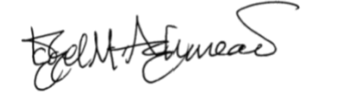

Dr I Ashmead
Assistant Headteacher SLT Link for KS3

