27th November 2024

Dear Parents/Carers,

RE: Implementation of One-Way System in F Block – Starting Monday 2nd December

I am writing to inform you about the introduction of a one-way system in F Block, which will come into effect on Monday 2nd December. This change is being implemented to ensure the safety and smooth movement of all students.

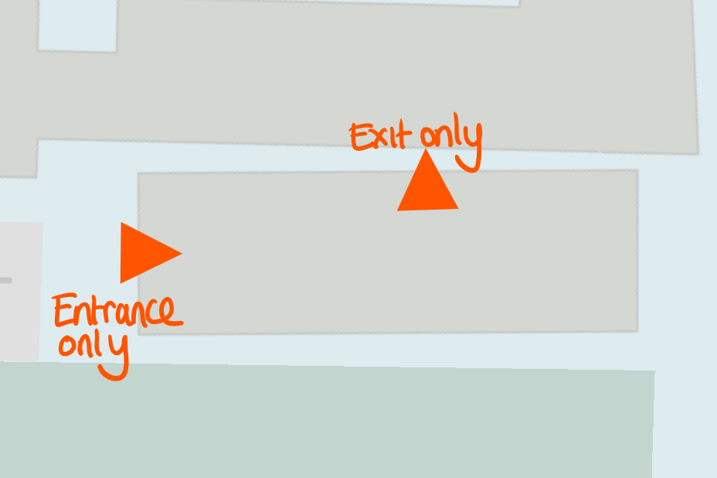

F Block has become increasingly congested during transitions between lessons. This not only creates delays, but also poses safety risks. The one-way system is designed to reduce congestion, improve safety and make transitions smoother for everyone.

All students across all year groups must follow the system at all times, including during transitions at the end of period 2 and period 4. The only exception is at the end of the school day. Students who fail to follow the one-way system will receive a C3 detention (60 minutes), as non-compliance with this safety measure disrupts order and poses potential risks.

Heads of Year will deliver this message to students ahead of the implementation date to ensure they are aware of the new system and its expectations. We kindly request your support in reinforcing this change with your child. Please remind them of the importance of following the one-way system to ensure a safe and smooth school environment.

Thank you for your cooperation.

Yours sincerely

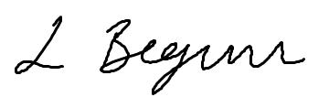

Lilika Begum
Head of English

